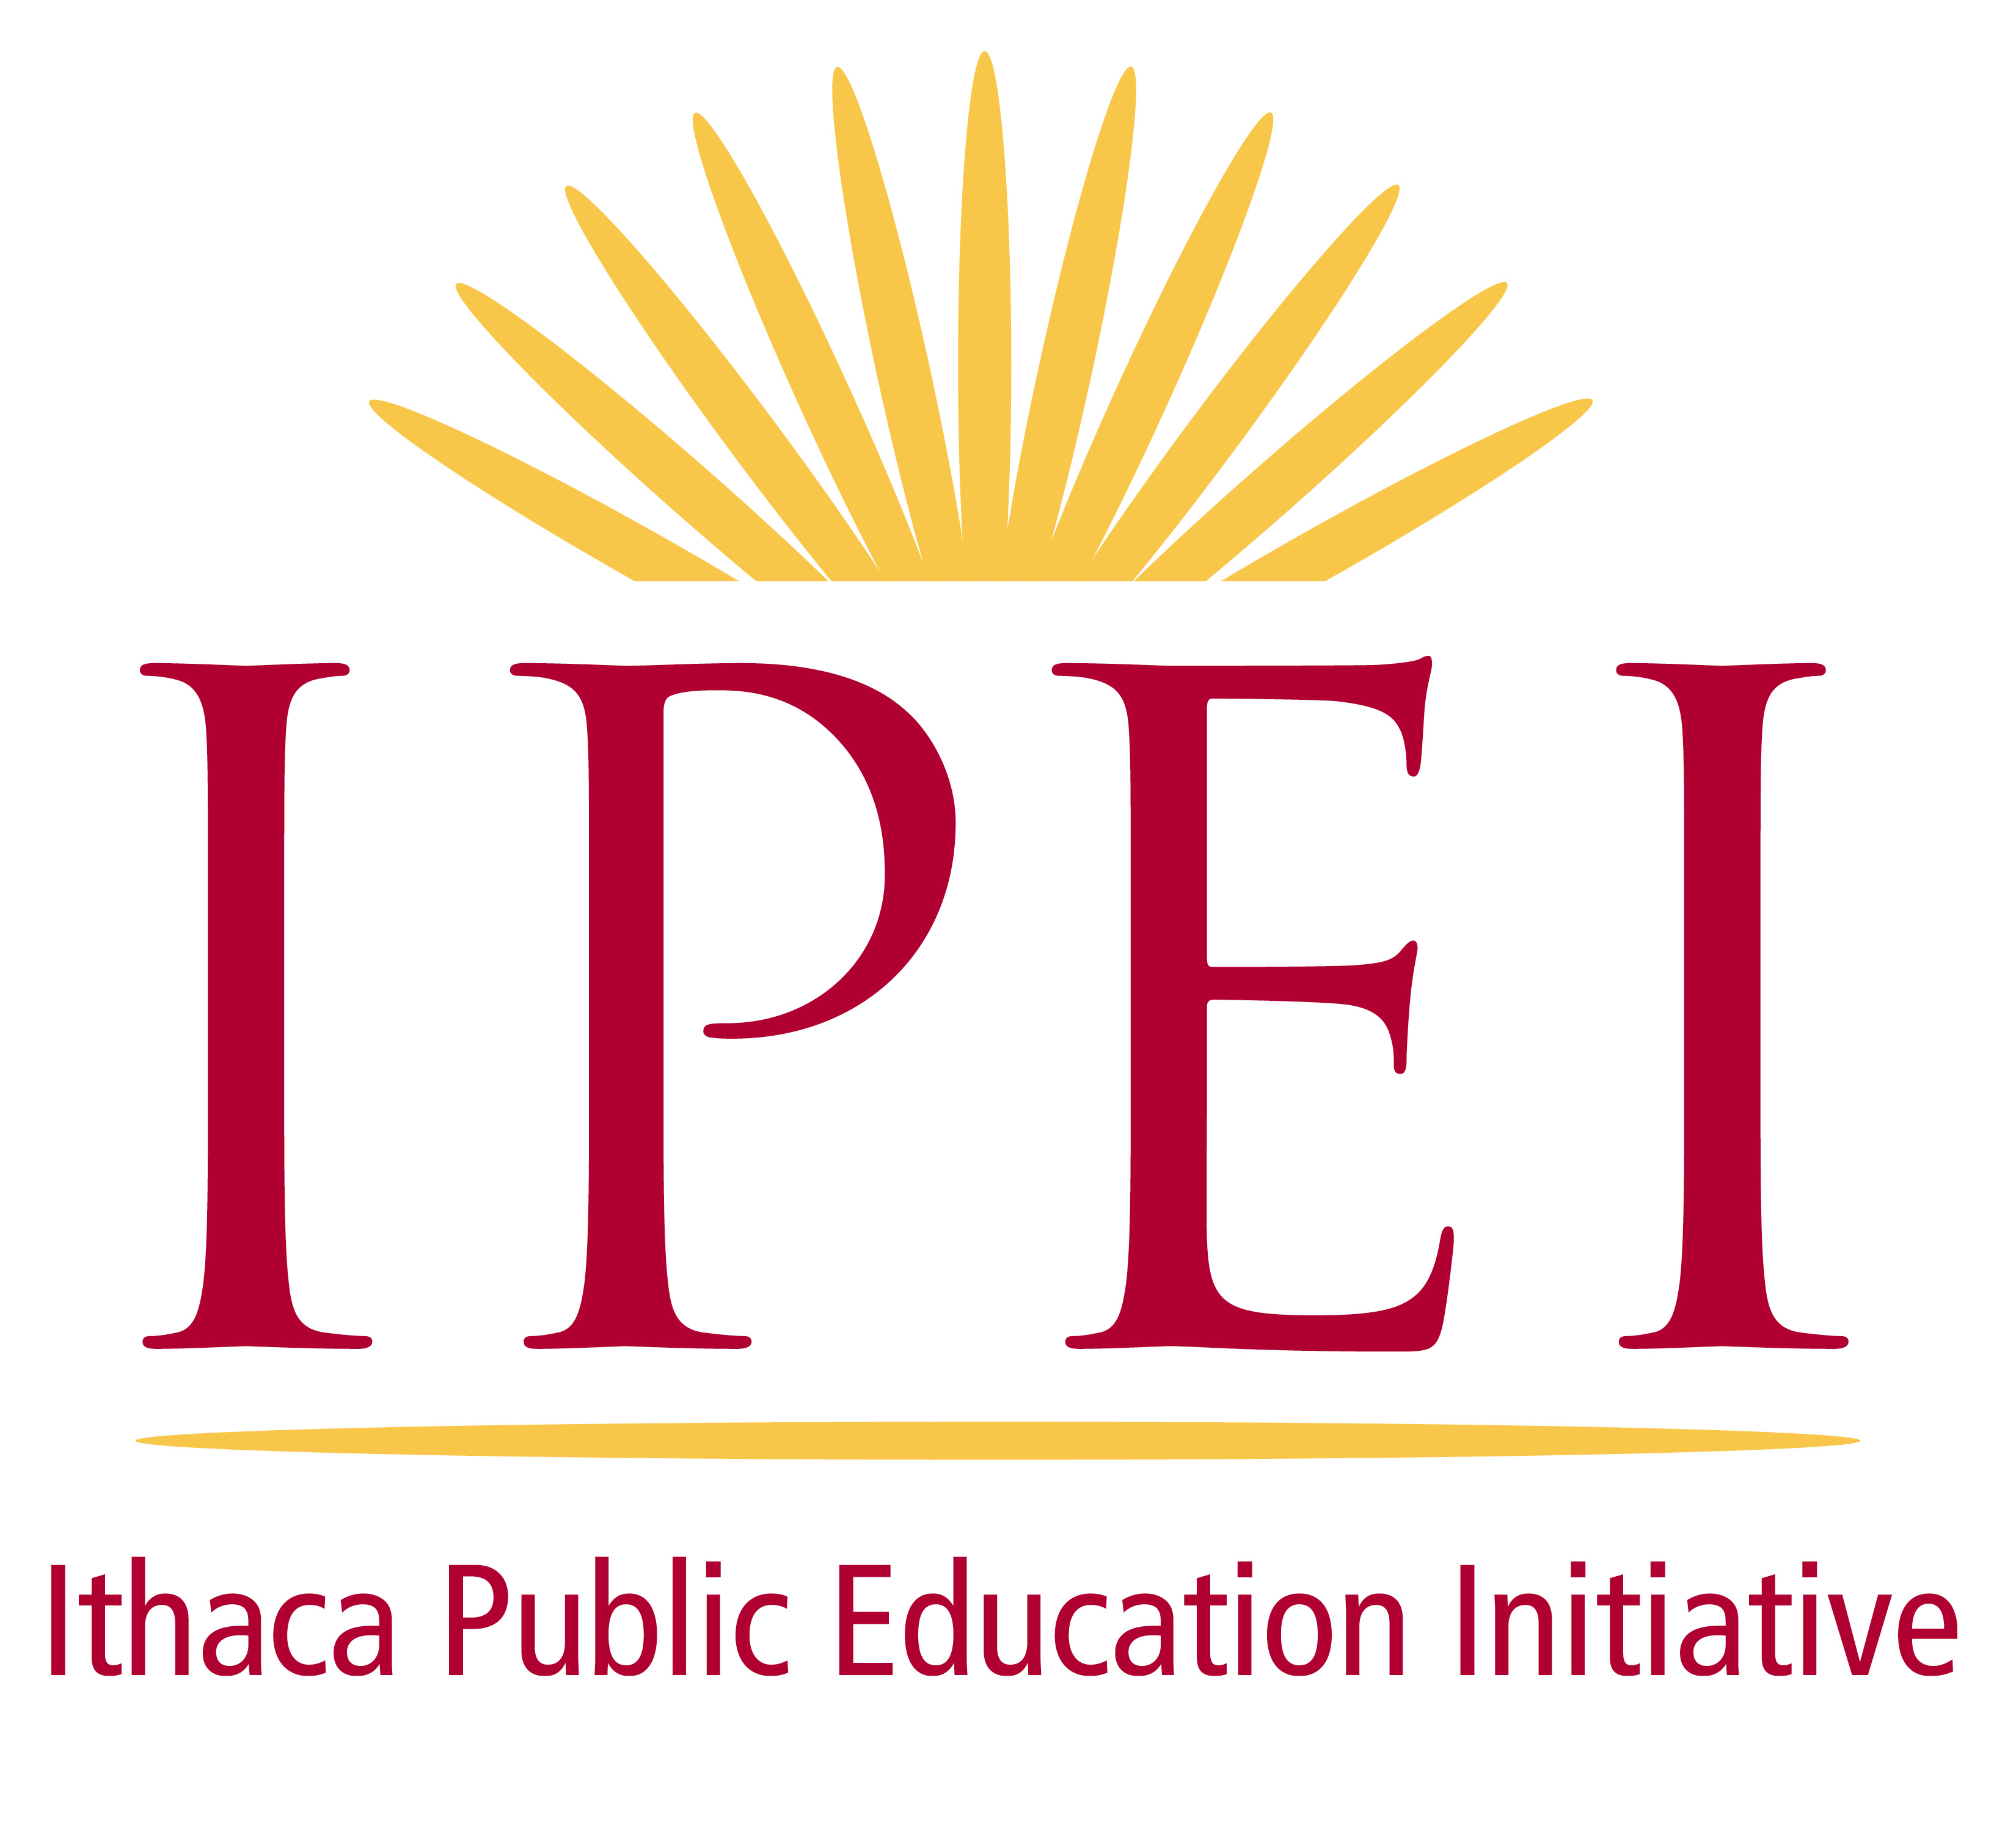

Welcome to the Brodhead Society

Thank you for your generous support and your deep commitment to the Ithaca Public Education Initiative through your planned gift. This gift will help ensure that future generations of Ithaca City School District students will reap the benefits of innovative programs and classroom activities supported by IPEI that connect our schools and our community.

We invite you to use this form to notify us of your legacy gift intentions. Notifying us of your estate plan does not imply a legal commitment, and you are under no obligation to follow the course of action you have outlined below. As IPEI does not provide financial or legal advice, we encourage you to consult your lawyer or financial advisor about your plans.

Name of donor(s):

Mailing address:

Phone: Email address:

Please let us know the terms of your estate gift.

A. Designation of gift:
- Unrestricted: Please use my gift in support of those areas with the greatest need.

- General endowment: Please add the proceeds to IPEI’s endowment.

- Other:

If other, please confer with an IPEI representative regarding IPEI’s planned gift acceptance policy.

B. Other information: Please share other information if possible, such as the type of gift (will, trust, life insurance policy, retirement plan, etc.) and terms of gift (specific dollar amount, percentage, asset, etc.).

Acknowledgement

IPEI recognizes and thanks those who have included IPEI in their estate plan or have made a planned gift to benefit the organization. With your permission it would be our pleasure to include you as a member of the Brodhead Society.

- I give IPEI permission to publish my/our name(s) in IPEI publications and donor acknowledgements. I wish my/our name to be listed in publications as follows:

- I wish my gift to remain anonymous.

Donor’s signature Date

Donor’s signature Date

